UAS-DTU

**Unmanned Aerial Systems Delhi Technological University**

**ROUND 2:**

**Technical Round Avionics Department**

# Task Statement

You are required to write a program such that a UAV traversing towards a specific target drop location estimates its current position and decides whether to drop payload or not for successful payload delivery at target point.

# Task Details

## Objective:

Develop a python function/script for Autonomous drop of Payload by a **moving** UAV using Haversine Formula such that a spherical Payload of 1.5 Kg drops along a **parabolic trajectory** in an **acceptable range of distance from drop Location** and **print a confirmation message** that payload has been Dropped. (Assume Air Drag Coefficient and Height of UAV)

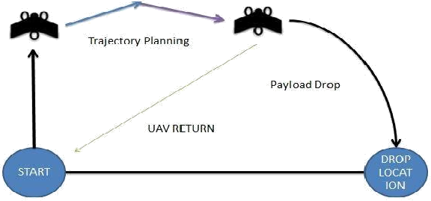

**SOURCE CODE:**

# 

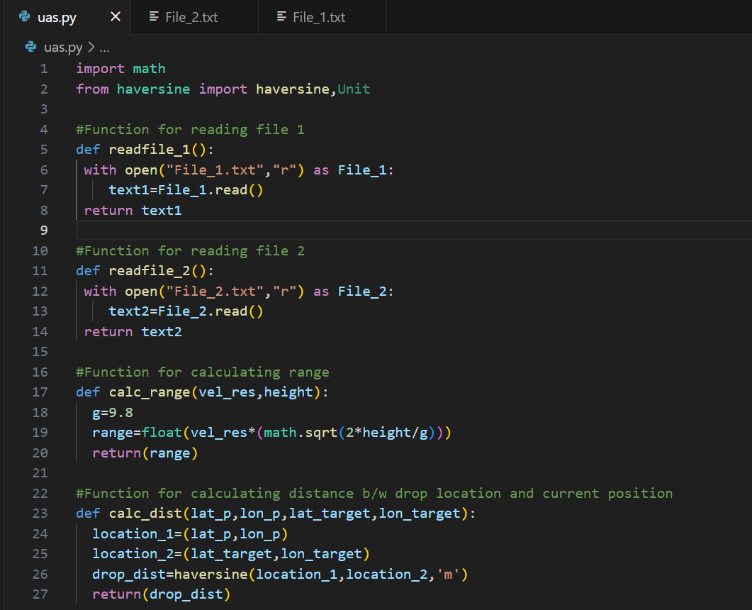

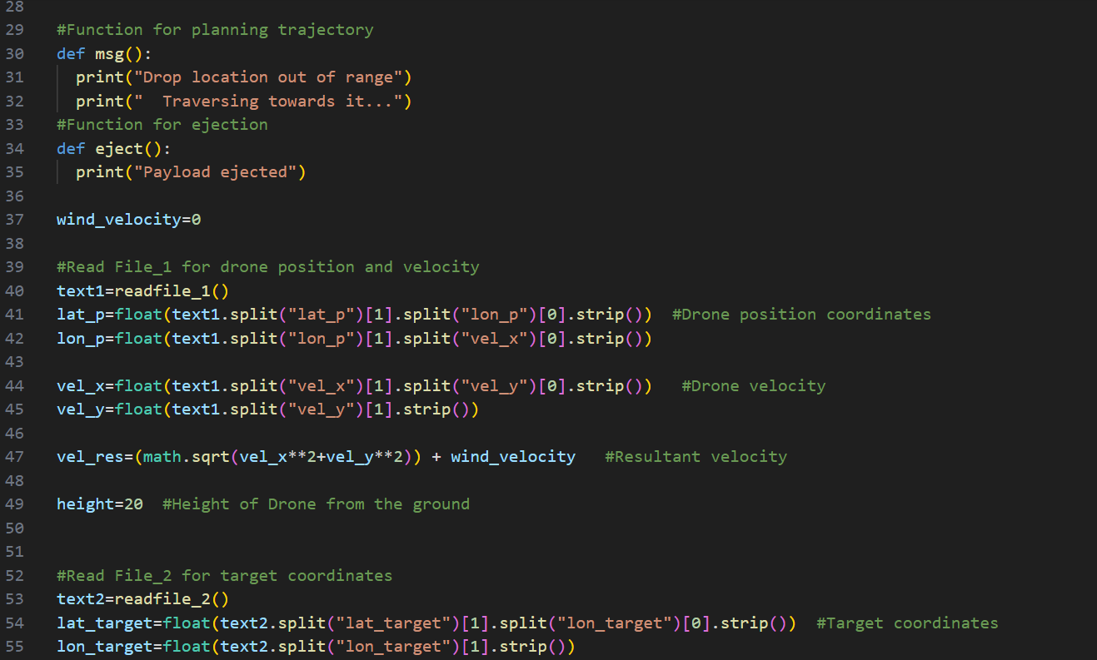

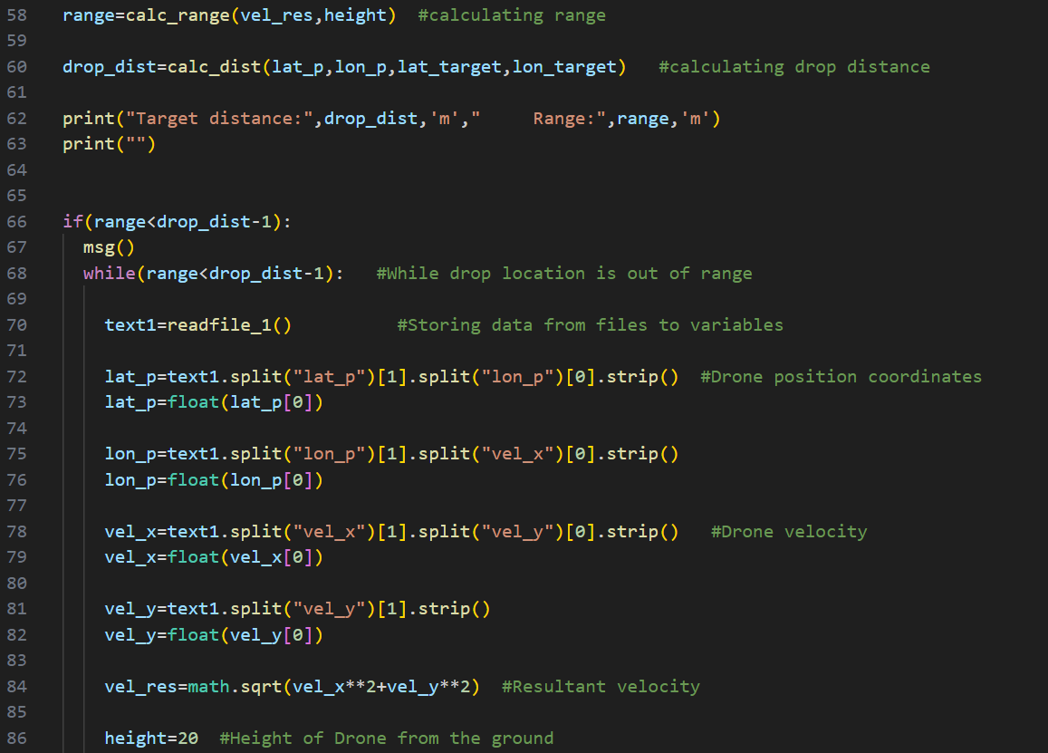

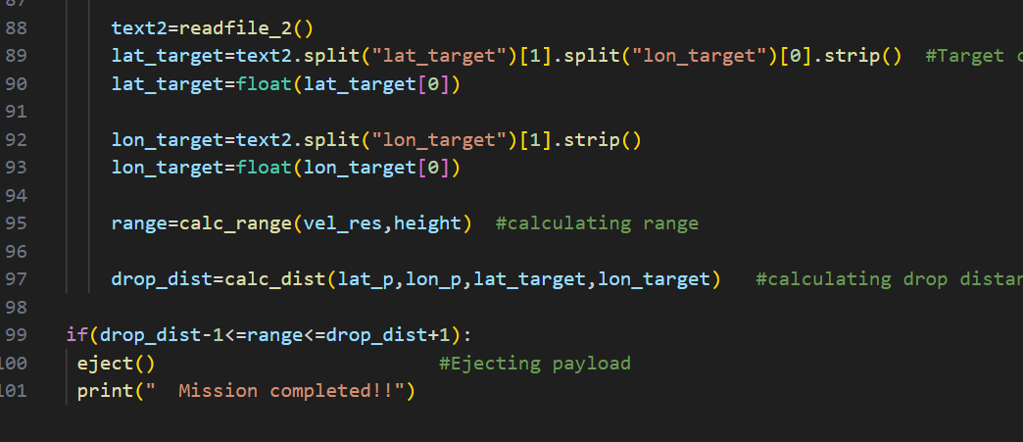**RESULT:**

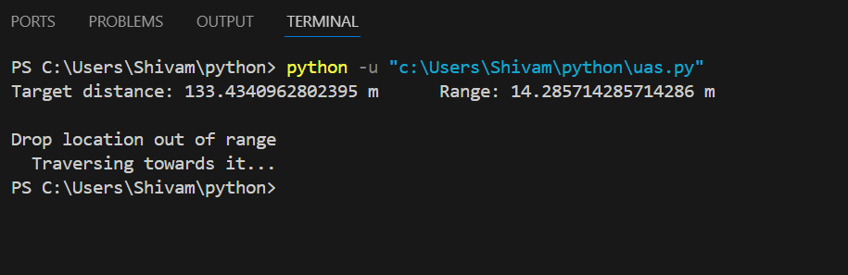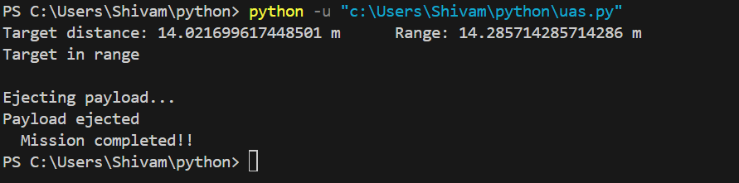 1)When drop location is out of range.

2)When drop location is in range.

**Pseudo code**

1. Read from file 1 (position, velocity)
2. Read file 2
3. Store it in variables
4. Calculate target distance
5. Calculate range using velocity and height
6. If range less than target distance repeat above using loop
7. When range = target distance => eject
8. Print confirmation message